**3. Tic Tac Toe Project – The GameBoard Instructions**

**Lab Goal :** This lab was designed to teach you more object oriented programming and how to write a very simple game. Also, this lab was designed to allow you to review matrices and graphics.

**Lab Description :** For this part of the Tic Tac Toe program, you are to write code to trap for mouse clicks on the screen. If the left mouse button is clicked on one of the squares on the Tic Tac Toe board, you are to instantiate a Piece with the name X and the proper location of where to draw the X on the graphics window and put the new Piece in the Grid. If the right mouse button is clicked on one of the squares in the Tic Tac Toe board, you are to instantiate a Piece with the name O and the proper location of where to draw the O on the graphics window and put the new Piece in the Grid.

When the Grid drawBoard method is called, each of the Pieces stored in the grid will be drawn on the screen. A Piece named X will be drawn as a green box that contains a green X. A Piece named O will be drawn as a red box that contains a red O.

Once you get the colored boxes and letters to show, you are then to make the game a fully playable Tic Tac Toe game. You would need to add in logic to make sure players alternate clicks and to check to see who has won once the game board has a full row, column, or diagonal.

**Files Needed ::**

**Locatable.java**

**Drawable.java**

**Nameable.java**

**Piece.java**

**Grid.java**

**GameBoard.java**

**TicTacToe.java**

**Sample Data :**

see below

**Sample Output :**

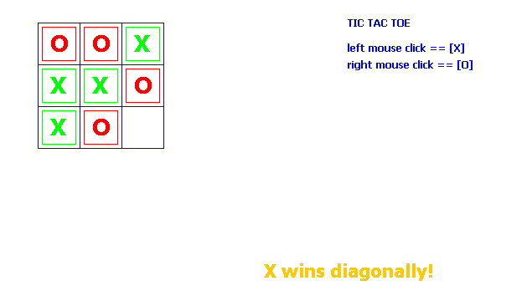

***EXTRA CREDIT***

**Convert TIC TAC TOE to Connect Four.**

**You will need to expand the grid.**